SECRET NOTES

🧠 What is the DOM?
DOM is a tree-like structure that represents the HTML page loaded in the browser.
It converts HTML into objects that JavaScript can access and modify.
👉 Simply:
HTML → Browser reads it → Converts to DOM → JavaScript can interact with it

🚀 Why We Use DOM?
Purpose | What it enables
📝 Dynamic Content | Change text, images, elements without reloading the page
🎨 Styling | Change CSS styles dynamically
🔘 User Interaction | Respond to clicks, inputs, keypresses
⚙ Add/Remove Elements | Create or delete elements in real time
🔄 Live Data Updates | Update UI from APIs (e.g., cart counters, search results)
💡 Event Handling | Detect and respond to UI events

💻 Example: Change Text on Button Click Using DOM
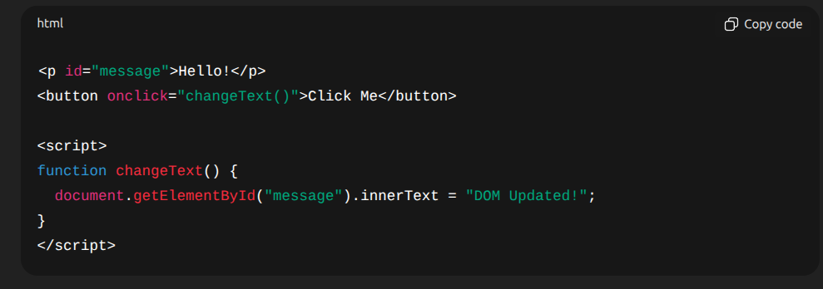
✔ No page reload
✔ The paragraph changes immediately using the DOM

🏁 Final Summary
We use DOM to make web pages dynamic, interactive, and updatable without reloading them.
It allows JavaScript to read, modify, and control HTML & CSS content in real-time.

🧠 What is an Event Listener?
It’s like telling the browser:
“When this thing happens on that element, run this function.”

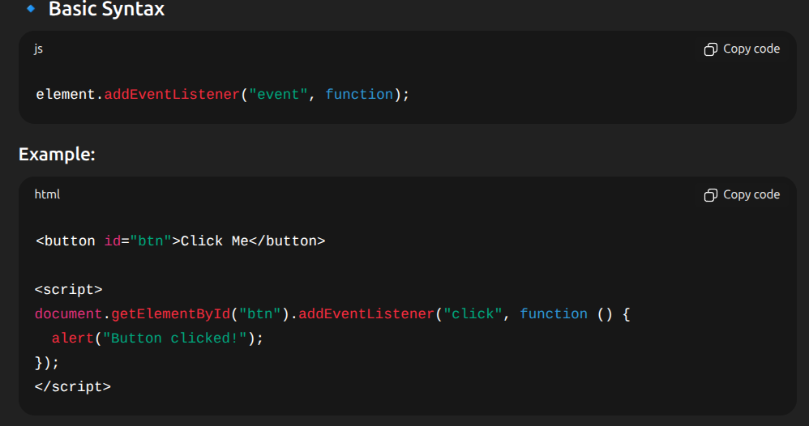
💡 Here:
- Element → button
- Event → "click"
- Action → alert("Button clicked!")

🎯 Common JS Events
User Action | Event Name
Click | "click"
Hover | "mouseover"
Typing | "keydown"
Input change | "input"
Page loaded | "load"
Scroll | "scroll"
Resize | "resize"
Submit form | "submit"

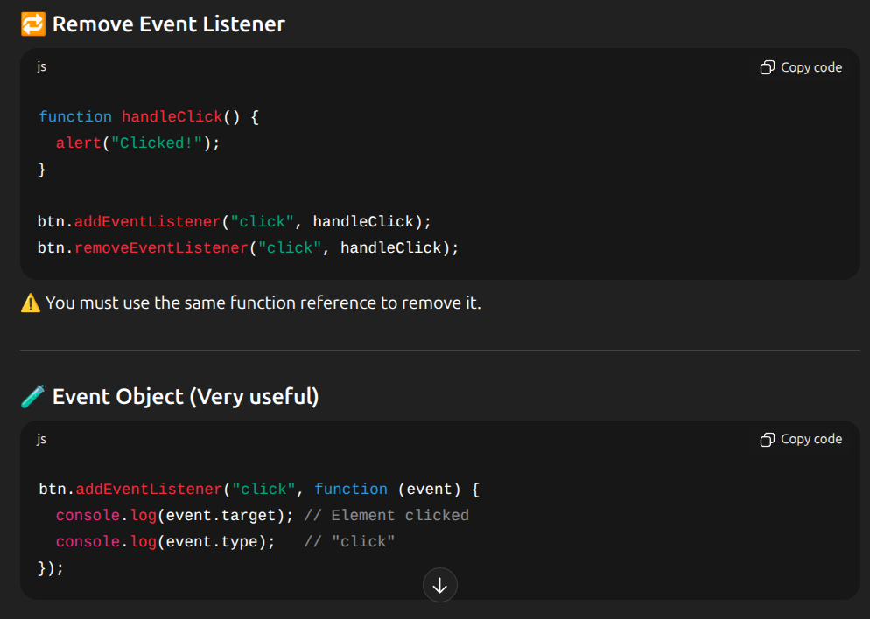

🚀 1. SSR — Server-Side Rendering

🔹 What it is?
SSR means your web page is rendered (HTML created) on the server, not in the browser.
👉 Browser requests → Server generates HTML → Sends fully rendered page to client.

🔍 Why use it?
Benefit | Reason
⚡ Faster First Load | Pre-rendered HTML arrives immediately
🔎 Better SEO | Search engines can easily read full page
🛠 Good for dynamic content | No need to wait for JS to generate UI

🧠 Where used?
- Next.js, Nuxt.js
- E-commerce sites (fast loading, SEO)
- Blogs, news sites

📌 Example (SSR)
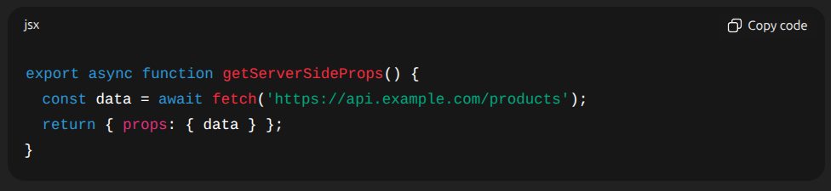

SSR | Using Client-Side Fetching (useEffect, fetch, axios, etc.)
Client → Request page  ↓  Server (Next.js) runs getServerSideProps()  ↓  API call happens (fetch)  ↓  Data received  ↓  Return { props: { data } }  ↓  Page renders using this data | Client → Request page  ↓  Page renders EMPTY (or with loader)  ↓  Browser runs useEffect()  ↓  API call from client  ↓  Data received  ↓  Component updates (re-render)

🌐 2. CDN — Content Delivery Network

🔹 What it is?
A CDN is a network of servers around the world that store cached static content (images, CSS, JS, fonts, videos, etc.)
👉 When a user opens a page → files are served from the nearest server → page loads faster.

🔍 Why use it?
Benefit | Reason
⚡ Faster loading | Files delivered from nearby server
🔒 More secure | DDoS protection
📈 High availability | Multiple servers → no downtime
💸 Reduces load on main server | Files cached elsewhere

💡 Examples
- Cloudflare, AWS CloudFront, Akamai
- Shopify uses CDN for product images

📌 Example
<img src="https://cdn.shopify.com/s/files/.../image.png">

📡 3. WebSockets

🔹 What it is?
WebSocket allows two-way, real-time communication between client and server.
Unlike normal HTTP (request → response → close), WebSocket keeps the connection open.
👉 "Server and client can talk anytime without reloading page."

🔍 Why use it?
Use Case | Example
💬 Live chat | WhatsApp Web
📢 Notifications | Shopify live inventory update
📊 Live updates | Stock prices, match scores
🔁 Multiplayer games | Real-time game actions

📌 Example (JavaScript WebSocket)
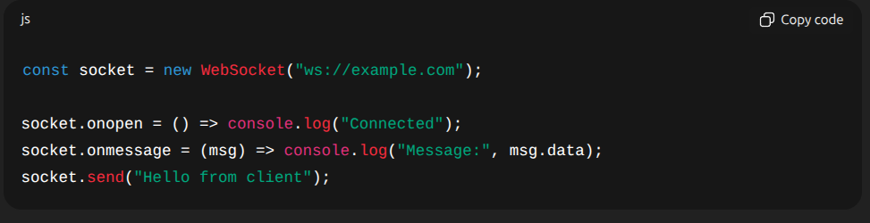

🆚 Quick Comparison
Feature | SSR | CDN | WebSocket
What it does | Renders page on server | Delivers static files globally | Real-time 2-way communication
Improves | SEO & speed | Page load speed | Live interactivity
Used for | Dynamic websites | Images, CSS, JS | Chat, notifications
Connection | One-time (HTTP) | One-time | Continuous

🏁 Final Summary
🔥 SSR → Pre-render pages on server → Fast & SEO friendly
🌎 CDN → Deliver static content from nearest server → Faster loading
💬 WebSockets → Live, real-time communication → No refresh needed

